THREADS
Multithreading is a Java feature that allows concurrent execution of two or more parts of a program for maximum utilization of CPU. Each part of such program is called a thread. So, threads are light-weight processes within a process.
Threads can be created by using two mechanisms:
- Extending the Thread class
- Implementing the Runnable Interface

Thread creation by extending the Thread class
We create a class that extends the java.lang.Thread class. This class overrides the run() method available in the Thread class. A thread begins its life inside run() method. We create an object of our new class and call start() method to start the execution of a thread. Start() invokes the run() method on the Thread object.

Thread creation by implementing the Runnable Interface
We create a new class which implements java.lang.Runnable interface and override run() method. Then we instantiate a Thread object and call start() method on this object.

Thread Class vs Runnable Interface
- If we extend the Thread class, our class cannot extend any other class because Java doesn’t support multiple inheritance. But, if we implement the Runnable interface, our class can still extend other base classes.
- We can achieve basic functionality of a thread by extending Thread class because it provides some inbuilt methods like yield(), interrupt() etc. that are not available in Runnable interface.
  - A yield() method is a static method of Thread class and it can stop the currently executing thread and will give a chance to other waiting threads of the same priority.
  - If any thread is in sleeping or waiting for a state then using the interrupt() method, we can interrupt the execution of that thread by showing InterruptedException. A thread that is in the sleeping or waiting state can be interrupted with the help of the interrupt()
- Using runnable will give you an object that can be shared amongst multiple threads.

Lifecycle and States of a Thread in Java
A thread in Java at any point of time exists in any one of the following states. A thread lies only in one of the shown states at any instant:
- New State
- Runnable State
- Blocked State
- Waiting State
- Timed Waiting State
- Terminated State
The diagram shown below represents various states of a thread at any instant in time.
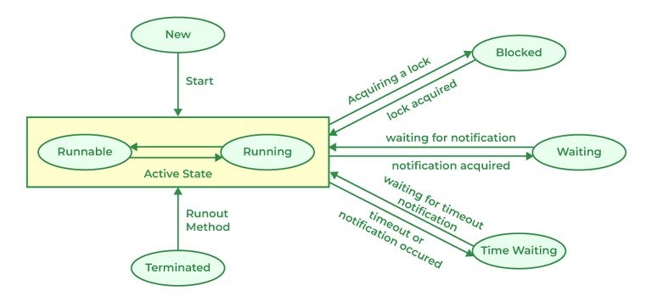

Life Cycle of a Thread
There are multiple states of the thread in a lifecycle as mentioned below:
- New Thread: When a new thread is created, it is in the new state. The thread has not yet started to run when the thread is in this state. When a thread lies in the new state, its code is yet to be run and hasn’t started to execute.
Thread state for a thread that has not yet started.
public static final Thread.State NEW

- Runnable State: A thread that is ready to run is moved to a runnable state. In this state, a thread might actually be running or it might be ready to run at any instant of time. It is the responsibility of the thread scheduler to give the thread, time to run.

Thread state for a runnable thread. A thread in the runnable state is executing in the Java virtual machine but it may be waiting for other resources from the operating system such as a processor.

public static final Thread.State RUNNABLE

A multi-threaded program allocates a fixed amount of time to each individual thread. Each and every thread runs for a short while and then pauses and relinquishes the CPU to another thread so that other threads can get a chance to run. When this happens, all such threads that are ready to run, waiting for the CPU and the currently running thread lie in a runnable state.

- Blocked: The thread will be in blocked state when it is trying to acquire a lock but currently the lock is acquired by the other thread. The thread will move from the blocked state to runnable state when it acquires the lock.

public static final Thread.State BLOCKED

- Waiting state: The thread will be in waiting state when it calls wait() method or join() method. It will move to the runnable state when other thread will notify or that thread will be terminated.
public static final Thread.State WAITING

- Timed Waiting: A thread lies in a timed waiting state when it calls a method with a time-out parameter. A thread lies in this state until the timeout is completed or until a notification is received. For example, when a thread calls sleep or a conditional wait, it is moved to a timed waiting state.
public static final Thread.State TIMED_WAITING

- Terminated State: A thread terminates because of either of the following reasons:
  - Because it exits normally. This happens when the code of the thread has been entirely executed by the program.
  - Because there occurred some unusual erroneous event, like a segmentation fault or an unhandled exception.

Declaration: public static final Thread.State TERMINATED

// Java program to demonstrate thread states
class thread implements Runnable {
public void run()
{
// moving thread2 to timed waiting state
try {
Thread.sleep(1500);
}
catch (InterruptedException e) {
e.printStackTrace();
}

System.out.println(
"State of thread1 while it called join() method on thread2 -"
+ Test.thread1.getState());
try {
Thread.sleep(200);
}
catch (InterruptedException e) {
e.printStackTrace();
}
}
}

public class Test implements Runnable {
public static Thread thread1;
public static Test obj;

public static void main(String[] args)
{
obj = new Test();
thread1 = new Thread(obj);

// thread1 created and is currently in the NEW
// state.
System.out.println(
"State of thread1 after creating it - "
+ thread1.getState());
thread1.start();

// thread1 moved to Runnable state
System.out.println(
"State of thread1 after calling .start() method on it - "
+ thread1.getState());
}

public void run()
{
thread myThread = new thread();
Thread thread2 = new Thread(myThread);

// thread1 created and is currently in the NEW
// state.
System.out.println(
"State of thread2 after creating it - "
+ thread2.getState());
thread2.start();

// thread2 moved to Runnable state
System.out.println(
"State of thread2 after calling .start() method on it - "
+ thread2.getState());

// moving thread1 to timed waiting state
try {
// moving thread1 to timed waiting state
Thread.sleep(200);
}
catch (InterruptedException e) {
e.printStackTrace();
}
System.out.println(
"State of thread2 after calling .sleep() method on it - "
+ thread2.getState());

try {
// waiting for thread2 to die
thread2.join();
}
catch (InterruptedException e) {
e.printStackTrace();
}
System.out.println(
"State of thread2 when it has finished it's execution - "
+ thread2.getState());
}
}
Output
State of thread1 after creating it - NEW
State of thread1 after calling .start() method on it - RUNNABLE
State of thread2 after creating it - NEW
State of thread2 after calling .start() method on it - RUNNABLE
State of thread2 after calling .sleep() method on it - TIMED_WAITING
State of thread1 while it called join() method on thread2 -WAITING
State of thread2 when it has finished it's execution - TERMINATED

